Use Cases Guidelines



Revision History

Version Number | Creation/  Revision Date | Prepared /Updated By | Reviewed By | Approved By | Change Description
1.0 | 04.07.2023 | Rajashree M. | Jayanta C. | Jayanta C. | Baseline version

Table of Contents

1 Objective 4
2 Scope 4
3 Purpose 4
4 What is Use Case? 4
5 Why Use Cases? 4
6 What Use Cases should contain? 4
7 How to define Use Cases? 5
8 Use Case Relationships 5
9 Use Case Specification Format 6
10 Diagrammatic Representation of Use Case 9
11 Use Case Example – Withdraw money from ATM 9

- Objective
The objective of this guideline is to help the Business Analyst and Project managers along with their whole project team to understand the activities related to Requirement management and Requirement development for the projects.

- Scope
This procedure is applicable to all the projects managed and controlled at **************** Ltd.
- Purpose
The purpose of this guideline is to describe the steps and procedures used in developing software requirements like High level requirements as well as low level functional and non-functional. These guidelines are intended to be a generic product which can be applied to almost any project anytime during its life cycle.
- What is Use Case?
A Use Case describes a sequence of interactions between a system and an external actor that results in the actor accomplishing a task that provides benefit to someone.
Any Use case has the following characteristics:
- Initiated by an actor.
- Concurrent (Time & Place).
- Self-Contained.
- Offers tangible value for the actor.
When a Use case has two Actors both on the LHS of the Ellipse. This implies that both actors are required for the Use Case to be performed. When there is an actor on the LHS and the RHS of the ellipse, this implies that the actor on the RHS enables the system to deliver value to the actor at the LHS. The LHS Actor need not know of the existence of RHS Actor.
- Why Use Cases?
Use Case approach is beneficial to the customer in the sense it shows exactly how the system works for users by providing step-by-step descriptions in a non-technical language.

Use cases can be used to drive the following processes:

- Analysis: Produce classes from use case descriptions
- Design: The detailed steps in the use case can help define the system sequences and also throw light on the user interface needed.
- Coding/Testing: The realization of each use case should be insured by coding/testing. (Coding will be translation of low level design / realized use case into software program)

- What Use Cases should contain?
Use Case should contain the following:

- The focus of writing use cases is for capturing the “what part “of the requirements and not how the requirements will be realized. (This is captured in Use case realization document).
- All the business rules specified by the client.
- When preparing the use cases, check if it is consistent with tagged requirements. It has to be ensured that all the requirements are completely addressed by the use cases.

Use Case should not contain the following:
- The algorithms that will be used for realizing the use case. This should be included in the use case realization document.
- All design related details like primary keys, validations of input / output fields should not from part of use cases.
- Watch for clues of design details creeping in
- Too many consecutive system steps should not be detailed in Use Cases.
- References to the database or other non-domain concepts
- Don’t use weak verbs e.g. System will generate report, transactions will be supported by the system
- How to define Use Cases?
Ideally every Use Case should be captured iteratively / incrementally.
First Iterations – This can be brief or casual, but it should include essential requirements.
Next Iterations – Add details – Fully dressed; still it should cover essential requirements.
Later Iterations get real – some implementation details
The Use Case should be written in the domain language only and the glossary should define all the domain specific terms used.
Computer specific jargons have to be avoided.

- Use Case Relationships
- Include Relationship
Include relationships should be used when a common component will be used by multiple use cases. (Use when sub units repeat)
- Extend Relationship
Whenever there is possibility of Use Case branching out into further self-contained sub units an external relationship should be used.
Refer to the diagram given below indicating both the relationships.
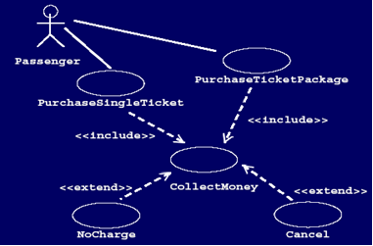

- Use Case Specification Format
Following are the elements of use cases.
- Use Case Tag: Unique identification name. The first word should be a verb e.g. Create Invoice, upload system data.
A Use Case is functionality provided by the system, typically described as verb+object (e.g. Register User, Delete User). Use Cases are depicted with an ellipse. The name of the use case is written within the ellipse.
Use Case Name

- Actor: An actor, as mentioned, is a user of the system, and is depicted using a stick figure. The role of the user is written beneath the icon. Actors are not limited to humans. If a system communicates with another application, and expects input or delivers output, then that application can also be considered an actor. The “Role” that initiates the use case. (Primary Actor/s; never including the system)

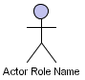

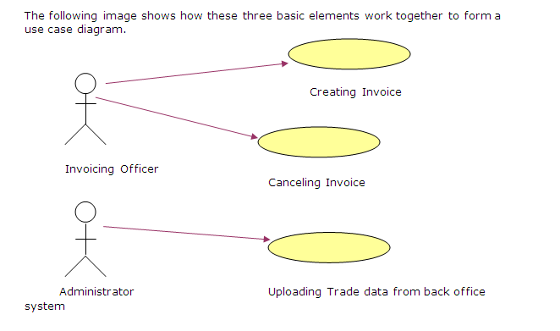
- Stakeholders: List candidate stakeholders who play this actor role.
- Pre-Condition: This is the required state of the system for success of the use case. Pre-conditions should make clear when a use case can execute E.g. an account must be in good standing and the daily withdrawal limit not exceeded in order to withdraw cash. Pre-conditions may be set by other systems. An account can be overdrawn through direct payments
- Main Paths: Undertake a Step-by-Step description of the interaction between the system & the Actor. It also describes how the system works to respond to the Actor.
Guidelines for writing the narrations.
- Start by writing a success story, a “happy path”. This should be the straight logical path (Main Path) e.g. Use case for Login should explain the flow of events that lead to successful login of the actor. This is the happy path. The unhappy path will be when the actor fails to log in., which should be covered in alternate flow of events.
- Define what information passes between the system and actor but don’t describe its format or details
- All actions should be visible to or easily surmised by the actor
- Convey what the application will do and how it will work
- Describe how the goal is achieved and end there.
Examples
Scenario 1: Make a recurring payment
This should include all the steps in paying monthly phone bill …
Scenario 2: Make a non-recurring payment
All the steps in paying a fixed amount …
Scenario 3: Make a regular payment
All the steps in paying a monthly loan …
- Post Condition: Describes the system after completion of use case. State of the system after completion of the use case.
- Alternative Path: This describes all the conditional paths including variations and exceptions as opposed to the main path.
Following two questions should be asked at each step in the main path
Q1. Is there some other action that can be taken at this point? (Variation)
Q2. Is there something that could go wrong here? (Exception)
Guidelines for writing alternative path
- Name it with descriptive phrase
- Identify the step of the main path it relates to. This is a very important step. This highlights the step from which the alternative path may emerge.
- Document what happens:
- Describe how it is resolved, or
- Write and refer to another scenario or conversation, or
- Use an activity diagram showing decisions and alternative paths if needed.
- Notes: Additional information that is important for better understanding of use case by the project team like:
- Details the input/ output/ validation/ batch process.
- Examples that clarify the Use case to the project team.
- Screen shots /reports shots etc.
- Reference Use Cases.

- Diagrammatic Representation of Use Case

Pre-Condition

Alt Step 3.2
Alt Step 3.1
Alt Step 2.2
Alternative Path 2

Alternative Path 1
Step 1
Step 2
Step 3
Step 4

Main Path

Success Failure

Success Failure

Success Failure

Post Condition

- Use Case Example – Withdraw money from ATM

Pre - Conditions
1. Actor has successfully logged into the system
2. Sufficient funds are available in actor’s account for withdrawal.

Main Path

S1 – Actor selects the option to withdraw money.

Alternative Path 1 <Actor Selects Fast Cash>

Alternative Path 2

S3.1 The system responds with an error message saying, “Cannot dispense the desired amount due to system error”.
S2 – System responds by displaying the options 1.Withdraw Cash 2. Fast Cash

S2.1 System responds by displaying pre – determined amounts

S2.2 Actor responds by selecting the pre -determined amount.
S3 – Actor selects the 1st option and keys in the required amount

S4 – The system responds by dispensing the desired amount.

Failure State <Actor Unable to withdraw cash>

Post Conditions
1. The system displays the login screen.

